National University of Computer and Emerging Sciences


Lab Manual 8
“Triggers”
Database Systems
Spring 2021

Department of Computer Science
FAST-NU, Lahore, Pakistan

Table of Contents
Objectives 3
Triggers 3
DML Triggers: 4
Syntax of (DML) Triggers: 4
‘Instead of’ and ‘After’ Triggers: 4
DML trigger Option: 4
Getting the affected tables inside the triggers: 5
1. For Trigger or After Trigger: 6
1.1 Insert Trigger 6
1.2 Delete Trigger 7
1.3 Update Trigger 7
2. Instead of Trigger 9
2.1 Insert Trigger 9
2.2 Delete Trigger 9
2.3 Update Trigger 10
3. Rollback in For Trigger 11
4. Same Trigger For All three Actions (Insert, Update and Delete) 12
5. Drop, Enable and Disable a Trigger 13
6. DDL Triggers 13
Syntax Of DDL 13
Triggers: 14
References: 14

Objectives
The purpose this lab is to know how the triggers work, types of triggers, how to create a trigger and what are the uses of triggers.

Triggers
Triggers are special kind of stored procedures that automatically execute when a DML or DDL statement associated with the trigger is executed. Each trigger will be associated with one DML or DDL statement. Unlike stored procedure triggers cannot be executed directly by application/user, they will ONLY be executed by DBMS in reaction to DML or DDL statement with which the trigger was associated.

Triggers can be divided in two categories depending on the type of statement they are associated with as follow:

- DML triggers
- DDL triggers
We shall use the schema from the last lab’s manual. Which is as follows.
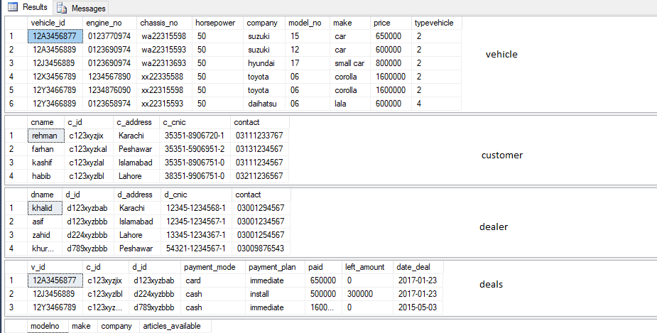
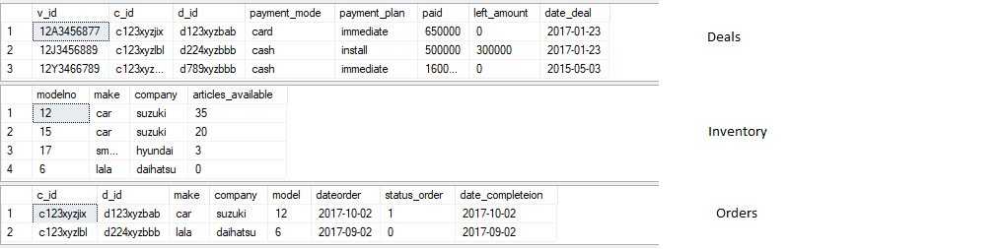

DML Triggers:
DML is the data modification language that uses queries like INSERT, UPDATE, DELETE. The DML triggers are used to handle these kind of queries.

Syntax of (DML) Triggers:

CREATE [ OR ALTER ] TRIGGER [ schema_name . ]trigger_name
ON { table }
[ WITH <dml_trigger_option> [ ,...n ] ]
{ (FOR | AFTER) | Instead of }
{ [ INSERT ] [ , ] [ UPDATE ] [ , ] [ DELETE ] }
AS { sql_statement [ ; ] [ ,...n ] }

<dml_trigger_option> ::=
[ NATIVE_COMPILATION ]
[ SCHEMABINDING ]
[ EXECUTE AS Clause ]

‘Instead of’ and ‘After’ Triggers:
You must have noticed the word after and instead of in the syntax of the trigger creation given above.
The instead of trigger is shot by stopping the action on which the trigger is created. However, the after (or for) trigger is shot after the action on which the trigger is created is complete.

DML trigger Option:
The DML trigger option given in the above syntax is used to specify the action on which the trigger is to be shot.
Now let us look at the triggers a little closely how they practically work.
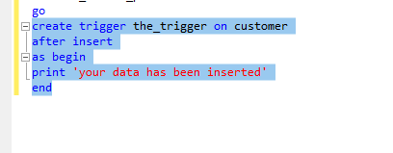

The trigger has been made as to be shot on the insert query on the customer table. Now if we insert anything in the customer table as soon as a new customer has been added in the table this trigger shall be shot.
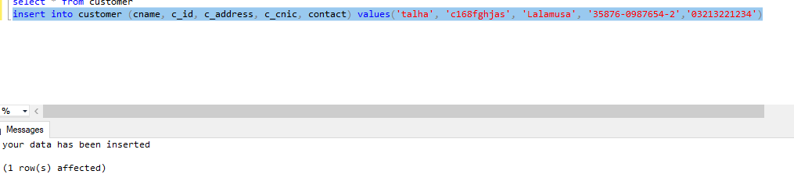
In the above example you can clearly see that we have just inserted a new entry in the table customer but the trigger has been shot that too after the trigger has been shot.
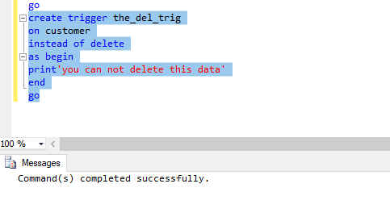

Getting the affected tables inside the triggers:
The triggers we have seen above are simple one, what if you want the value of effect rows from DML and use them in triggers.

Example: Whenever a customer is inserted in, it should automatically convert that name of that instructor in Upper Case.
For example: customer with Name “ali ahmed” should be inserted as “ALI AHMED”

For that we use special table “DELETED” and “INSERTED” designed for DML triggers.

DML triggers use the deleted and inserted logical (conceptual) tables. They are structurally similar to the table on which the trigger is defined, that is, the table on which the user action is tried. The deleted and inserted tables hold the old values or new values of the rows that may be changed by the DML action.
NOTE: These tables are only accessible in triggers

For Trigger or After Trigger:
A For or After trigger is fired after the intended action takes place.

Insert Trigger
A for trigger defined on a table for insert operation is fired after the insert statement is executed. Consider the following For trigger for insert operation on Customers Table.
Create Trigger ForTriggerForInsertCustomer
On Customers
For Insert
AS
Begin
declare @customerNo varchar(2),
@name varchar(30),
@city varchar(3),
@phone varchar(11)

Select @customerNo= Inserted.customerNo, @name=Inserted.name, @city=Inserted.city, @phone= Inserted.phone
From Inserted

print ('New Customer Inserted whose customerNo is '+@customerNo+'. Name is '+@name+'. City is '+@city+'. Phone is '+@phone+'.')
End

The above trigger will be called after the insert operation on customers. The insert operation will be carried out as usual and after that the trigger will be called.
Insert into Customers values('C0', 'Ali', 'Lhr', '12345')
When the above insert statement is executed, we get the following output:

Delete Trigger
A for trigger defined on a table for delete operation is fired when the delete statement is executed. Consider the following For trigger for delete operation on Customers Table:
Create Trigger ForTriggerForDeleteCustomer
On Customers
For Delete
AS
Begin
declare @customerNo varchar(2),
@name varchar(30),
@city varchar(3),
@phone varchar(11)

Select @customerNo= Deleted.customerNo,
@name=Deleted.name,
@city=Deleted.city,
@phone= Deleted.phone
From Deleted

print ('A Customer deleted whose customerNo is '+@customerNo+'. Name is '+@name+'. City is '+@city+'. Phone is '+@phone+'.
')
End

The above trigger will be called after the delete operation on customers. The delete operation will be carried out as usual and after that the trigger will be called.
When the following delete operation is called:
Delete From Customers
where CustomerNo='C0'
We get the output as follows:
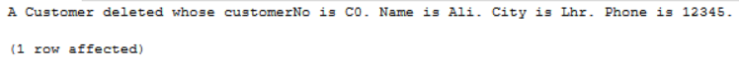

Update Trigger
A for trigger defined on a table for update operation is fired when the update statement is executed. Consider the following For trigger for update operation on Customers Table:

Create Trigger ForTriggerForUpdateCustomer
On Customers
For Update
AS
Begin
declare @oldCustomerNo varchar(2),
@oldName varchar(30),
@oldCity varchar(3),
@oldPhone varchar(11),

@newCustomerNo varchar(2),
@newName varchar(30),
@newCity varchar(3),
@newPhone varchar(11)

Select @oldCustomerNo= Deleted.customerNo,
@oldName=Deleted.name,
@oldCity=Deleted.city,
@oldPhone= Deleted.phone
From Deleted

Select @newCustomerNo= Inserted.customerNo,
@newName=Inserted.name,
@newCity=Inserted.city,
@newPhone= Inserted.phone
From Inserted

declare @messageString varchar(100)
set @messageString='The record of a customer updated. The fields that have been updated are: '

if @oldCustomerNo!=@newCustomerNo
Begin
set @messageString=@messageString+'Customer No,'
End

if @oldName!= @newName
Begin
set @messageString= @messageString+'Name, '
End

if @oldPhone!= @newPhone
Begin
set @messageString= @messageString+'Phone, '
End

if @oldCity!= @newCity
Begin
set @messageString= @messageString+'City'
End

print (@messageString)
End
When the following update statement is run:
Update Customers
set Name='Imran', city='Khr'
where CustomerNo='C2'
We get the output as follows:

Instead of Trigger
AS the name suggest, this type of trigger, when defined on insert, update, or delete operation, is called instead of the insert, update, and delete operation itself. So if we want the original insert, update or delete operation to be carried out successfully, we must do it in the trigger.

Insert Trigger
Create Trigger InsteadTriggerForInsertCustomer
On Customers
Instead of Insert
AS
Begin
declare @customerNo varchar(2),
@name varchar(30),
@city varchar(3),
@phone varchar(11)

Select @customerNo= Inserted.customerNo, @name=Inserted.name, @city=Inserted.city, @phone= Inserted.phone
From Inserted

Insert into Customers values (@customerNo, @name, @city, @phone)

print ('New Customer Inserted (by the trigger) whose customerNo is '+@customerNo+'. Name is '+@name+'. City is '+@city+'. Phone is '+@phone+'.')
End
When we run the following insert statement:
Insert into Customers values ('C0', 'Ali', 'Khr', '01234')
The output we get is as follows:
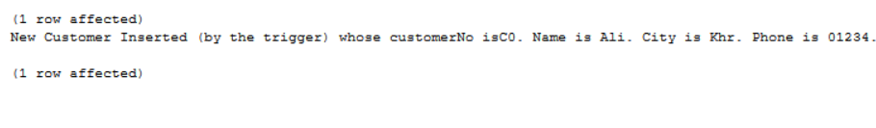

Delete Trigger
create Trigger InsteadTriggerForDeleteCustomer
On Customers
Instead of Delete
AS
Begin
declare @customerNo varchar(2),
@name varchar(30),
@city varchar(3),
@phone varchar(11)

Select @customerNo= Deleted.customerNo,
@name=Deleted.name,
@city=Deleted.city,
@phone= Deleted.phone
From Deleted

delete from Customers
where CustomerNo=@customerNo

print('Customer whose customer id is '+@customerNo+' deleted by trigger sucessfully')
End
When we run the following statement:
Delete From Customers
where CustomerNo='C2'

The output we get is as follows (The actual insert will be carried out by trigger itself):
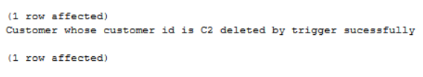

Update Trigger
Create Trigger InsteadTriggerForUpdateCustomer
On Customers
Instead of Update
AS
Begin
declare @oldCustomerNo varchar(2),
@oldName varchar(30),
@oldCity varchar(3),
@oldPhone varchar(11),

@newCustomerNo varchar(2),
@newName varchar(30),
@newCity varchar(3),
@newPhone varchar(11)

Select @oldCustomerNo= Deleted.customerNo,
@oldName=Deleted.name,
@oldCity=Deleted.city,
@oldPhone= Deleted.phone
From Deleted

Select @newCustomerNo= Inserted.customerNo,
@newName=Inserted.name,
@newCity=Inserted.city,
@newPhone= Inserted.phone
From Inserted

update Customers
set CustomerNo=@newCustomerNo, Name=@newName, city= @newCity, Phone= @newPhone
where CustomerNo= @oldCustomerNo

declare @messageString varchar(100)
set @messageString='The record of a customer updated by the trigger. The fields that have been updated are: '

if @oldCustomerNo!=@newCustomerNo
Begin
set @messageString=@messageString+'Customer No,'
End

if @oldName!= @newName
Begin
set @messageString= @messageString+'Name, '
End

if @oldPhone!= @newPhone
Begin
set @messageString= @messageString+'Phone, '
End

if @oldCity!= @newCity
Begin
set @messageString= @messageString+'City'
End

print (@messageString)
End

When the following update statement is called:
Update Customers
set Name='Imran', city='Khr'
where CustomerNo='C2'
We get the output as follows (The actual update will be done by the trigger itself)
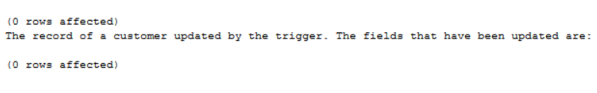

Rollback in For Trigger
If you do not want to carry out the insert, update or delete operation due to any reason. Then you can either write an instead trigger which will do the insert, update or delete operation only when the conditions are met. Alternatively, you can do rollback in for trigger if the conditions are not met.
Create Trigger ForTriggerOnInsertCustomer
on Customers
For Insert
AS
Begin
declare @name varchar(10)

Select @name=name from Inserted

if @name is NULL
Begin
rollback
End

End
The above trigger does not allow inserting the customer whose name is null. So, when the following insert statement is run, the insert operation will be rolled back by the trigger:
Insert into Customers values('C0', NULL, 'Lhr', '123')
We get the output as follows: 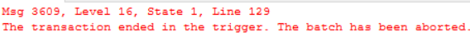

Same Trigger For All three Actions (Insert, Update and Delete)
So far we have seen triggers on a single action a single trigger can be used to cater multiple actions.
Before moving forward you must know that only one trigger can be made on a particular action on a table so in order to make a new trigger on the same action we should either alter the previous trigger or drop the previous trigger or disable it. The syntax for these are as follows.
ALTER <TriggerName>
On <view/table>
After/Instead of <insert/update/delete>
As
begin
<Body>
end
Create Trigger DisallowChangeOnCustomers
On Customers
Instead of Insert, Update, Delete
As
Begin
print ('Customer table is not allowed to be modified')
End

Drop, Enable and Disable a Trigger
Drop trigger <TriggerName>
Enable trigger <TriggerName> on <ObjectName>
Disable trigger <TriggerName> on <ObjectName>

disable trigger InsteadTriggerForInsertCustomer on Customers

DDL Triggers
DDL triggers, fire in response to a DDL statement to which they are associated. DDL event primarily correspond to SQL statements that start with the keywords CREATE, ALTER, and DROP. These triggers are current databases.

There triggers are also of two types, FOR and AFTER, first one executes instead of the DDL statement it is associated with and second one executes after the DDL statement, it is associate with is successfully executed.
(For in DML FOR is same as Instead of in DDL)

Use DDL triggers when you want to do the following:
- You want to prevent certain changes to your database schema.
- You want something to occur in the database in response to a change in your database schema.
- You want to record changes or events in the database schema.

Syntax Of DDL
CREATE TRIGGER trigger_name
ON DATABASE
{ FOR | AFTER } { event_type} [ ,...n ]
AS
Begin
<Body>
End

Triggers:
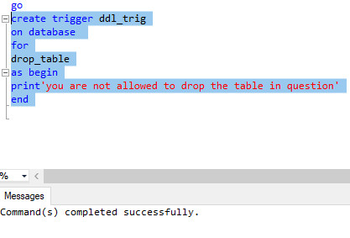

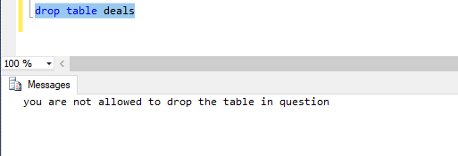

References:
https://msdn.microsoft.com/en-us/library/bb522542.aspx

